**Дата**: 29.11.2024

**Клас**: 9-Б

**Предмет**: англійська мова

**Тема:** Активні підлітки.

**Мета:** : формувати навички вживання лексичних одиниць по темі; удосконалювати навички читання, аудіювання й усного монологічного мовлення; розвивати пізнавальні інтереси учнів; виховувати інтерес до самостійного пошуку потрібної інформації, а також загальну культуру учнів.

**Вчитель**: Руда Д.В.

Хід уроку

1.Greeting

Good afternoon, guys! I’m glad to see you. Are you ready to start our

lesson? All set?

2. Wаrm up / Listening

Уважно слухати аудіо трек і дати відповідь на питання вчителя усно <https://www.youtube.com/watch?v=STwChkJbzPs> .

3. Speaking

As a teenager, what do you think you can contribute to society?

At what age should teenagers leave home?

What type of punishment did your parents use when you were a teenager?

Do you think teenagers today have it "too easy'?

Did you have a good relationship with your parents? Why or why not?

What do you think are some important things parents can do for teenagers?

Do you think teenagers today show respect for adults? Teachers? Parents? Brothers and sisters?

What do you think about teenagers who dye their hair blue, green, or another crazy color?

Do you think that wearing uniforms to school is a good idea?

At what age did you leave home?

What would you do if your teenage son or daughter got a tattoo?

What would you do if your teenage son or daughter shaved his or her head?

How do you feel about swearing?

Does it matter if teenagers sometimes use bad language?

What do you think about rock videos today?

What do you think parents can do to help teenagers avoid depression?

Do you believe in anti depression drugs?

4. Повторення

Повторення **past perfect**.

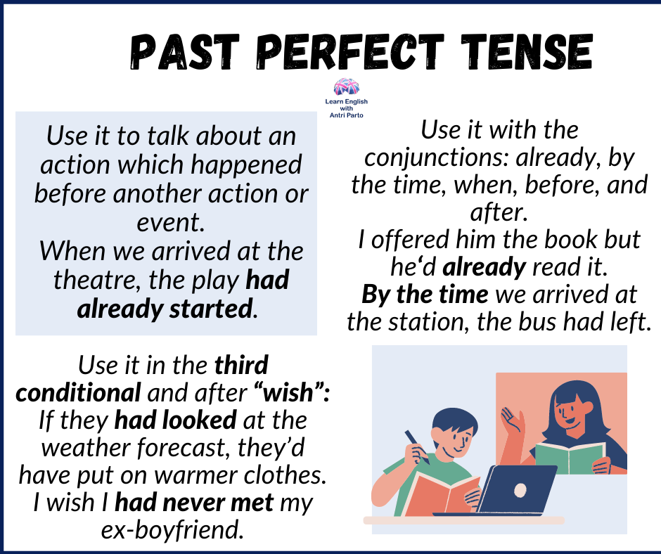

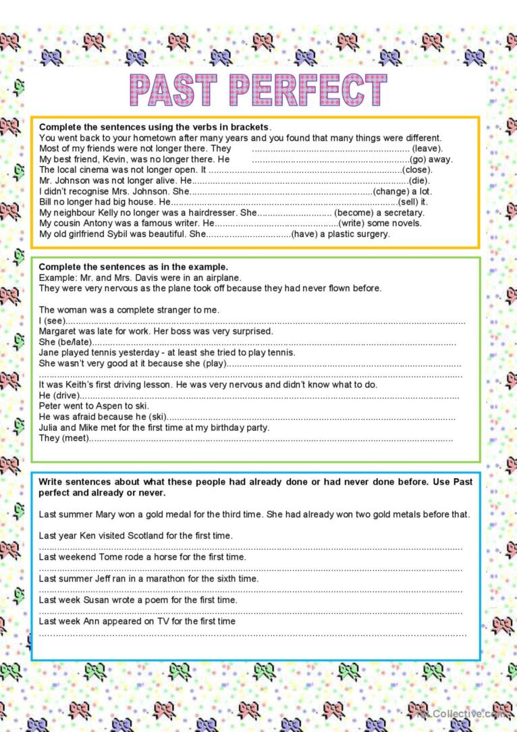

5. Writing

Виконати вправу 13 стр 105-106.

6. Homework

1. Виконати письмово вправу 15 стр 107.

2. Повторити професії.